 VINOD SIR’S GROUP TUTION

MARKS: 15 MATHS-VIII TIME: 1 Hr. 30 Mins.

Q. 1: Solve the following sum: [2]
The numbers of pages of a book Ninad read for five cosecutive days were 60, 50, 54, 46, 50. Find the average number of pages he read everyday.

Q. 2: The following table shows the number of saplings planted by 30 students. Fill in the boxes and find the average number of saplings planted by each student. [2]
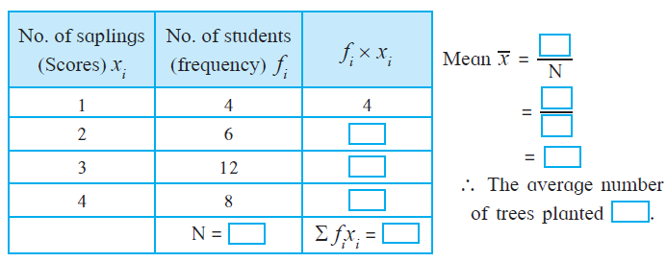
Q. 3: The following table shows the electricity (in units) used by 25 families of Eklara village in a month of May. Complete the table and answer the following questions. [4]
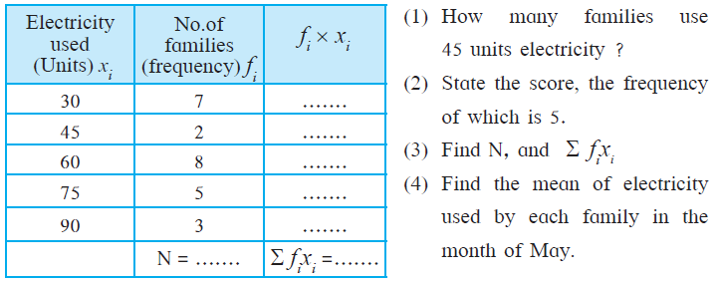
Q. 4: The number of boys and girls, in std 5 to std 8 in a Z.P. school is given in the table. Draw a subdivided bar graph to show the data. (Scale ः On Y axis, 1cm= 10 students) [3]
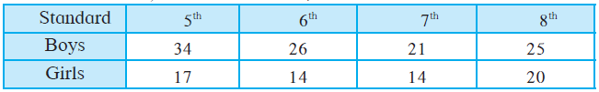

Q. 5: The number of members in the 40 families in Bhilar are as follows: [4]
1, 6, 5, 4, 3, 2, 7, 2, 3, 4, 5, 6, 4, 6, 2, 3, 2, 1, 4, 5, 6, 7, 3, 4, 5, 2, 4, 3,
2, 3, 5, 5, 4, 6, 2, 3, 5, 6, 4, 2. Prepare a frequency table and find the mean
of members of 40 families.

